**WEEK 4**

**SPRING REST**

**MANDATORY**

1. **Create a Spring web project using maven**

SpringLearnApplication.java

**package** com.cognizant.spring_learn;

**import** org.springframework.boot.SpringApplication;

**import** org.springframework.boot.autoconfigure.SpringBootApplication;

**import** org.slf4j.Logger;

**import** org.slf4j.LoggerFactory;

@SpringBootApplication

**public** **class** SpringLearnApplication {

**private** **static** **final** Logger ***LOGGER*** = LoggerFactory.*getLogger*(SpringLearnApplication.**class**);

**public** **static** **void** main(String[] args) {

SpringApplication.*run*(SpringLearnApplication.**class**, args);

***LOGGER***.info("Inside main method");

}

}

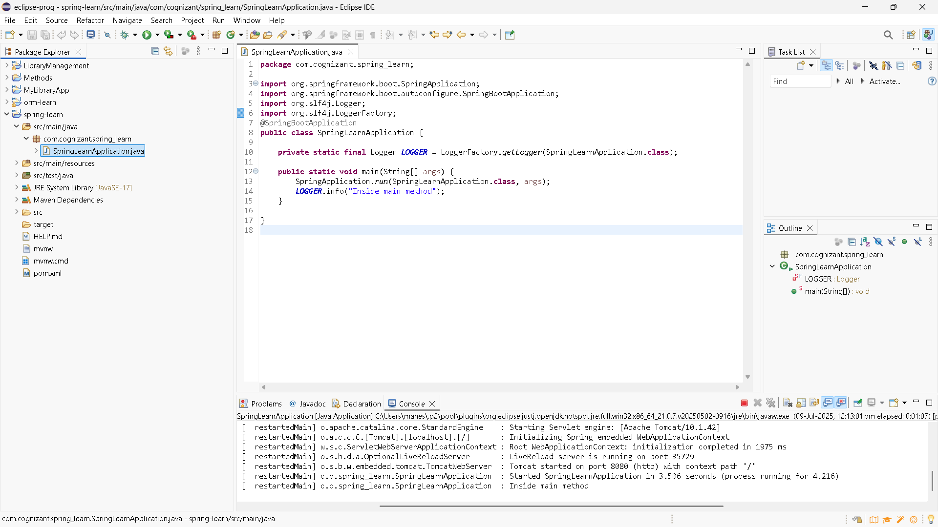

2) **Load Country from Spring Configuration XML**

Country.xml

<?xml version="1.0" encoding="UTF-8"?>

<beans xmlns="http://www.springframework.org/schema/beans"

xmlns:xsi="http://www.w3.org/2001/XMLSchema-instance"

xsi:schemaLocation="http://www.springframework.org/schema/beans

https://www.springframework.org/schema/beans/spring-beans.xsd">

<bean id="country" class="com.cognizant.spring_learn.Country">

<property name="code" value="IN"/>

<property name="name" value="India"/>

</bean>

</beans>

Country.java

package com.cognizant.spring_learn;

import org.slf4j.Logger;

import org.slf4j.LoggerFactory;

public class Country {

private static final Logger LOGGER = LoggerFactory.getLogger(Country.class);

private String code;

private String name;

public Country() {

LOGGER.debug("Inside Country Constructor.");

}

public String getCode() {

LOGGER.debug("Inside getCode()");

return code;

}

public void setCode(String code) {

LOGGER.debug("Inside setCode()");

this.code = code;

}

public String getName() {

LOGGER.debug("Inside getName()");

return name;

}

public void setName(String name) {

LOGGER.debug("Inside setName()");

this.name = name;

SpringLearnApplication.java

package com.cognizant.spring_learn;

import com.cognizant.spring_learn.Country;

import org.slf4j.Logger;

import org.slf4j.LoggerFactory;

import org.springframework.context.ApplicationContext;

import org.springframework.context.support.ClassPathXmlApplicationContext;

public class SpringLearnApplication {

private static final Logger LOGGER = LoggerFactory.getLogger(SpringLearnApplication.class);

public static void main(String[] args) {

LOGGER.info("START");

displayCountry();

LOGGER.info("END");

}

public static void displayCountry() {

ApplicationContext context = new ClassPathXmlApplicationContext("country.xml");

Country country = context.getBean("country", Country.class);

LOGGER.debug("Country : {}", country.toString());

}

}

logback.xml

<configuration>

<appender name="STDOUT" class="ch.qos.logback.core.ConsoleAppender">

<encoder>

<pattern>%d{HH:mm:ss.SSS} [%thread] %-5level %logger{36} - %msg%n</pattern>

</encoder>

</appender>

<logger name="com.cognizant" level="DEBUG"/>

<root level="INFO">

<appender-ref ref="STDOUT" />

</root>

</configuration>

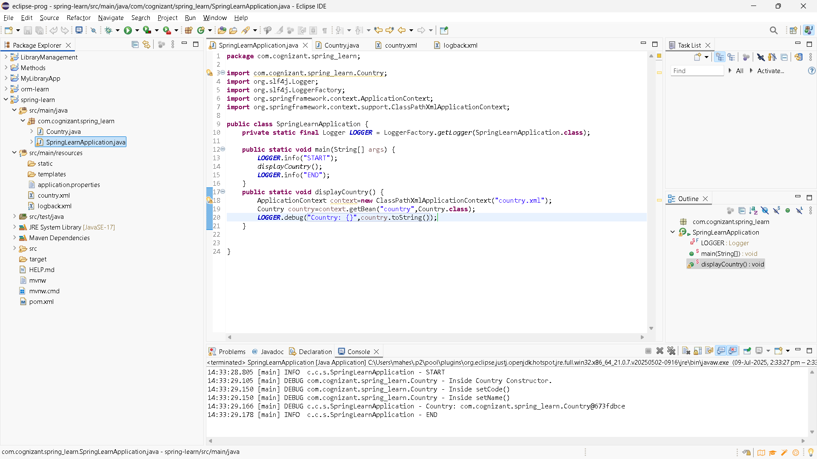

3) **Hello World RESTful Web Service**

**package** com.cognizant.spring_learn.controller;

**import** org.slf4j.Logger;

**import** org.slf4j.LoggerFactory;

**import** org.springframework.web.bind.annotation.GetMapping;

**import** org.springframework.web.bind.annotation.RestController;

@RestController

**public** **class** HelloController {

**private** **static** **final** Logger ***LOGGER*** = LoggerFactory.*getLogger*(HelloController.**class**);

@GetMapping("/hello")

**public** String sayHello() {

***LOGGER***.debug("START: sayHello()");

String message = "Hello World!!";

***LOGGER***.debug("END: sayHello()");

**return** message;

}

}

Application.properties

spring.application.name=spring-learn

logging.level.root=debug

server.port=8083

Pom.xml

<dependencies>

<dependency>

<groupId>org.springframework.boot</groupId>

<artifactId>spring-boot-starter-web</artifactId>

</dependency>

<dependency>

<groupId>org.springframework.boot</groupId>

<artifactId>spring-boot-starter-logging</artifactId>

</dependency>

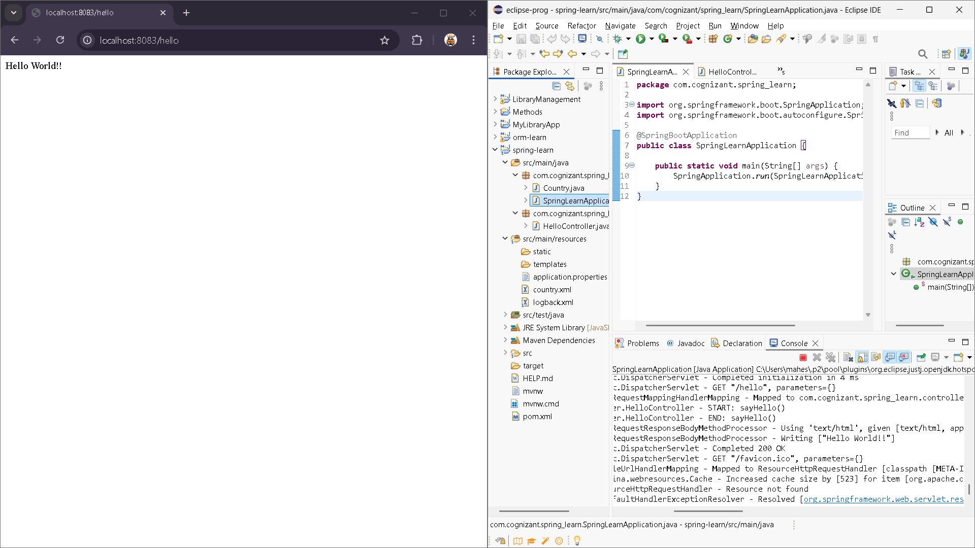

4) **REST - Country Web Service**

Country.xml

<?xml version="1.0" encoding="UTF-8"?>

<beans xmlns="http://www.springframework.org/schema/beans"

xmlns:xsi="http://www.w3.org/2001/XMLSchema-instance"

xsi:schemaLocation="

http://www.springframework.org/schema/beans

http://www.springframework.org/schema/beans/spring-beans.xsd">

<bean id="country" class="com.cognizant.springlearn.Country">

<property name="code" value="IN"/>

<property name="name" value="India"/>

</bean>

</beans>

Country.java

package com.cognizant.springlearn;

import com.fasterxml.jackson.annotation.JsonProperty;

public class Country {

@JsonProperty("code")

private String code;

@JsonProperty("name")

private String name;

public Country() {

// Default constructor

}

public String getCode() {

return code;

}

public void setCode(String code) {

this.code = code;

}

public String getName() {

return name;

}

public void setName(String name) {

this.name = name;

}

@Override

public String toString() {

return "Country{" + "code='" + code + '\'' + ", name='" + name + '\'' + '}';

}

}

countryController.java

package com.cognizant.springlearn.controller;

import com.cognizant.springlearn.Country;

import org.slf4j.Logger;

import org.slf4j.LoggerFactory;

import org.springframework.context.ApplicationContext;

import org.springframework.context.support.ClassPathXmlApplicationContext;

import org.springframework.web.bind.annotation.RequestMapping;

import org.springframework.web.bind.annotation.RestController;

@RestController

public class CountryController {

private static final Logger LOGGER = LoggerFactory.getLogger(CountryController.class);

@RequestMapping("/country")

public Country getCountryIndia() {

LOGGER.debug("START: getCountryIndia()");

ApplicationContext context = new ClassPathXmlApplicationContext("country.xml");

Country country = context.getBean("country", Country.class);

LOGGER.debug("END: getCountryIndia() - {}", country);

return country;

}

}

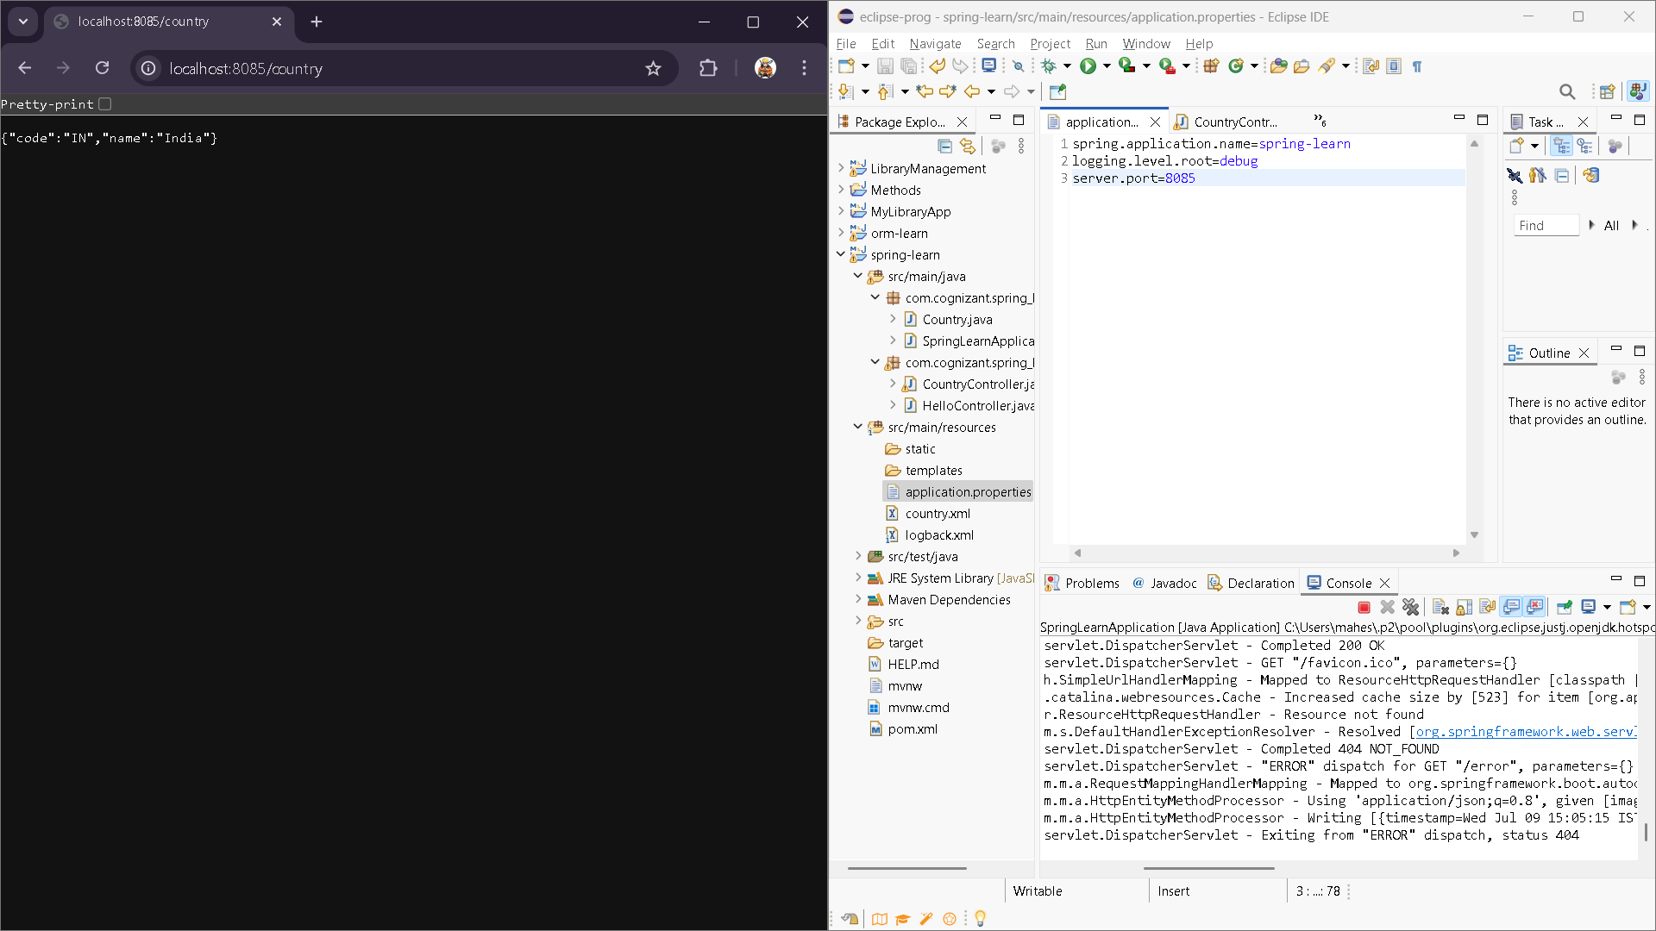

5) **REST - Get country based on country code**

Country.xml

<?xml version="1.0" encoding="UTF-8"?>

<beans xmlns="http://www.springframework.org/schema/beans"

xmlns:xsi="http://www.w3.org/2001/XMLSchema-instance"

xsi:schemaLocation="

http://www.springframework.org/schema/beans

http://www.springframework.org/schema/beans/spring-beans.xsd">

<bean id="countryList" class="java.util.ArrayList">

<constructor-arg>

<list>

<bean class="com.cognizant.springlearn.Country">

<property name="code" value="IN" />

<property name="name" value="India" />

</bean>

<bean class="com.cognizant.springlearn.Country">

<property name="code" value="US" />

<property name="name" value="United States" />

</bean>

<bean class="com.cognizant.springlearn.Country">

<property name="code" value="DE" />

<property name="name" value="Germany" />

</bean>

<bean class="com.cognizant.springlearn.Country">

<property name="code" value="JP" />

<property name="name" value="Japan" />

</bean>

</list>

</constructor-arg>

</bean>

</beans>

countryService.java

package com.cognizant.springlearn.service;

import com.cognizant.springlearn.Country;

import org.springframework.context.ApplicationContext;

import org.springframework.context.support.ClassPathXmlApplicationContext;

import org.springframework.stereotype.Service;

import java.util.List;

@Service

public class CountryService {

public Country getCountry(String code) {

ApplicationContext context = new ClassPathXmlApplicationContext("country.xml");

List<Country> countryList = context.getBean("countryList", List.class);

return countryList.stream()

.filter(country -> country.getCode().equalsIgnoreCase(code))

.findFirst()

.orElse(null);

}

}

CountryController.java

package com.cognizant.springlearn.controller;

import com.cognizant.springlearn.Country;

import com.cognizant.springlearn.service.CountryService;

import org.slf4j.Logger;

import org.slf4j.LoggerFactory;

import org.springframework.beans.factory.annotation.Autowired;

import org.springframework.web.bind.annotation.*;

@RestController

public class CountryController {

private static final Logger LOGGER = LoggerFactory.getLogger(CountryController.class);

@Autowired

private CountryService countryService;

@GetMapping("/country")

public Country getCountryIndia() {

LOGGER.debug("START: getCountryIndia()");

Country country = countryService.getCountry("IN");

LOGGER.debug("END: getCountryIndia()");

return country;

}

@GetMapping("/country/{code}")

public Country getCountry(@PathVariable String code) {

LOGGER.debug("START: getCountry() with code {}", code);

Country country = countryService.getCountry(code);

LOGGER.debug("END: getCountry() - {}", country);

return country;

}

}

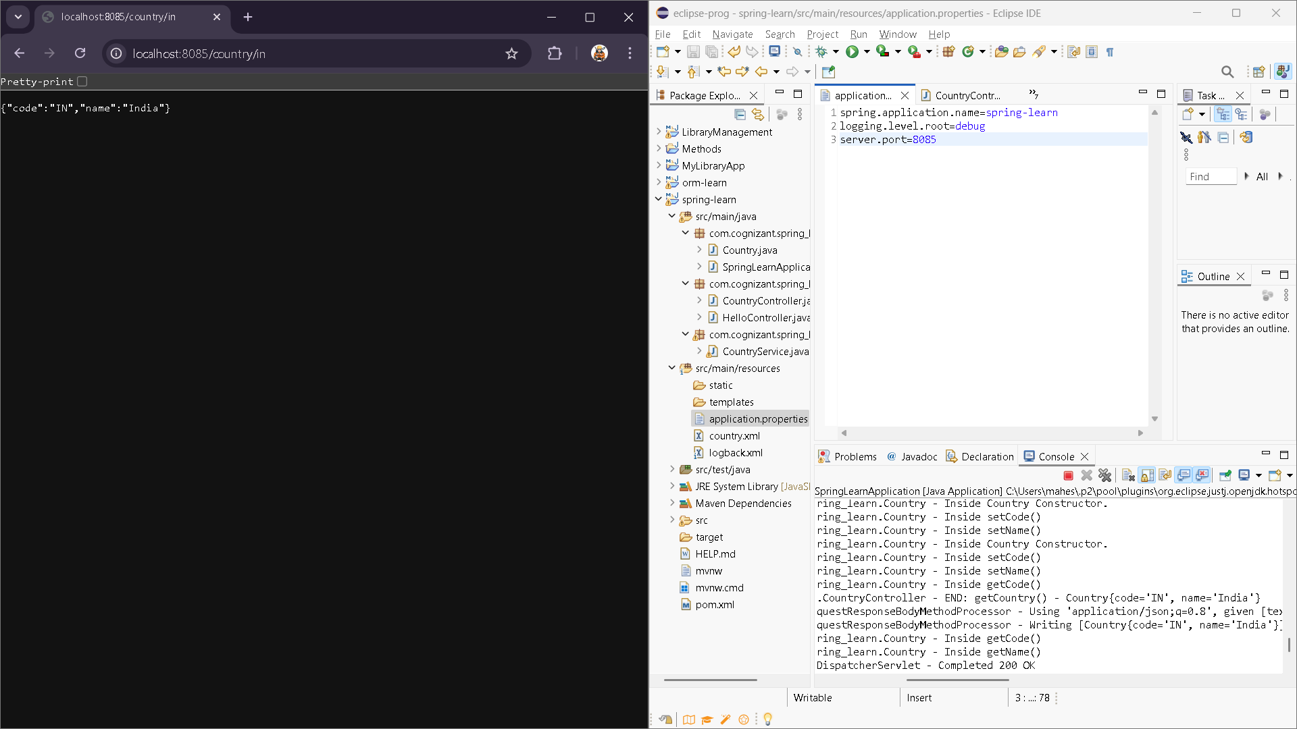

6) **Create authentication service that returns JWT**

Security.java

**package** com.cognizant.spring_learn.security;

**import** org.springframework.context.annotation.Bean;

**import** org.springframework.context.annotation.Configuration;

**import** org.springframework.security.config.annotation.web.builders.HttpSecurity;

**import** org.springframework.security.web.SecurityFilterChain;

**import** org.springframework.security.config.annotation.web.configuration.EnableWebSecurity;

**import** org.springframework.security.core.userdetails.User;

**import** org.springframework.security.core.userdetails.UserDetails;

**import** org.springframework.security.core.userdetails.UserDetailsService;

**import** org.springframework.security.provisioning.InMemoryUserDetailsManager;

**import** org.springframework.security.crypto.password.NoOpPasswordEncoder;

**import** org.springframework.security.crypto.password.PasswordEncoder;

**import** **static** org.springframework.security.config.Customizer.*withDefaults*;

@Configuration

@EnableWebSecurity

**public** **class** SecurityConfig {

@Bean

**public** SecurityFilterChain filterChain(HttpSecurity http) **throws** Exception {

http

.authorizeHttpRequests(auth -> auth

.requestMatchers("/country/**").hasRole("USER")

.requestMatchers("/authenticate").hasAnyRole("USER", "ADMIN")

.anyRequest().authenticated()

)

.httpBasic(*withDefaults*()) // updated line

.csrf(csrf -> csrf.disable()); // disable CSRF

**return** http.build();

}

@Bean

**public** UserDetailsService userDetailsService() {

UserDetails user = User.*withUsername*("user")

.password("pwd")

.roles("USER")

.build();

UserDetails admin = User.*withUsername*("admin")

.password("adminpwd")

.roles("ADMIN")

.build();

**return** **new** InMemoryUserDetailsManager(user, admin);

}

@SuppressWarnings("deprecation")

@Bean

**public** PasswordEncoder passwordEncoder() {

**return** NoOpPasswordEncoder.getInstance();

}

}

